CTM-I Test Plan

Menu Tab: Firm Maintenance

Screen: ORS Correspondent Conversion

Version 0.1

Menu Tab: Firm Maintenance

Use Case Name | ORS Correspondent Conversion
User Roles | Firm User (CTMI_Firm_Options_Clerk), Market Ops (CTMI_Help_Desk), Ops (CTMI_Form_options_Root), App Support (CTMI_Root)
Pre-conditions /Assumptions | User has successfully logged into the CTM-I application.
Post Conditions | None
Screenshot | 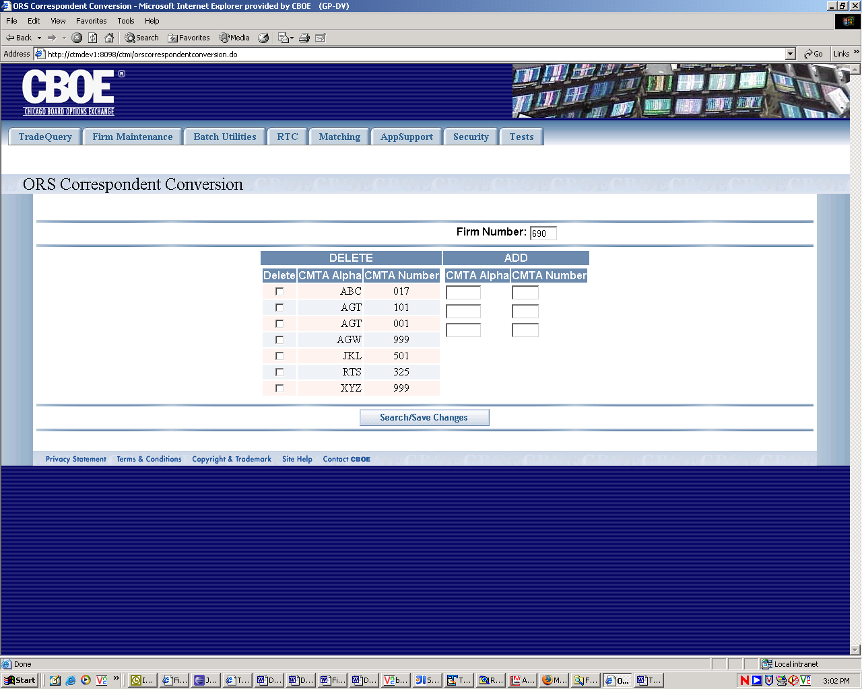
Test Scenario A | User Role : CTMI_Firm_Options_Clerk, User Id: xxx Password: xxx
 | Action | Expected Out Come | Comments/Results
Test Case 1  Display ORS Conversion Screen | User clicks on ORS Correspondent Conversion Menu | ORS Correspondence Conversion Screen displays with CMTA Alpha and CMTA Number data for the Primary Firm on the ORS Correspondence Column and three rows of blank text fields namely CMTA Alpha, CMTA Number on the Add column. Firm Number field at the top becomes a drop down list populated with all the Primary Firm and Authorized firms for this user.
Test Case 2  Search | User selects Firm Number in the named field and Clicks Save/Search button. | In ORS Correspondence Column the screen displays the existing CMTA alpha and CMTA numbers for the selected firm with ‘Delete’ checkbox on each row, and three rows of blank text fields namely CMTA Alpha, CMTA Number on the Add column. Firm Number field at the top becomes a drop down list populated with all the Primary Firm and Authorized firms for this user. | If no matching data exist no rows are returned.  All rows are returned on the same page. May have to scroll down for large amount of data rows.
Test Case 3  Delete | User selects CMTA to be deleted (Check Box marked) and clicks Save/Search button | The rows with marked checkbox are deleted. | If ‘Delete’ is successful
 |  | Error Message appears on the screen if ‘delete’ fails for some reason. | Alternate Flow  If ‘Delete’ fails
Test Case 4  Add | User enters CMTA Alpha and CMTA Number in one or more rows on the Add column and Clicks Save/Search button | Firms are added to the database and these new firms are displayed on the ‘Delete’ Column. | If additions are successful only. – Basic Flow
 | User enters a CMTA alpha which already exits and Clicks Save/Search button | Addition fails - Entry CMTA Alpha already exists | Alternate Flow
 | User enters a invalid CMTA alpha (more than 3 character or any character other than A~Z, a~z) and Clicks Save/Search button | Error Message – CMTA Alpha must belong A~Z or a~z and must be limited to Max 3 characters only. | Alternate Flow
 | User enters invalid (non numeric or more than 3 digits) CMTA number and Clicks Save/Search button | Error Message – CMTA number must be numeric and limited to Max 3 digits only. If less than 3 digits left padded with 0. | Alternate Flow
 | User enters valid CMTA alpha Only and Clicks Save/Search button | Error Message - CMTA Number is required. Please enter a CMTA Number
 | User Enters valid CMTA Number Only and Clicks Save/Search button | Error Message - CMTA Alpha is required. Please enter a valid CMTA Alpha
 | User enters CMTA alpha with numeric characters | Error Message - CMTA Alpha must be A~Z or a~z. Please enter a valid CMTA Alpha | Does require client side syntactic validation? Use case does not specify.
 | User enters CMTA numbers with alpha characters | Error Message - CMTA Number must be numeric only. Please enter a valid CMTA Number
 | User Enters more than 3 digit number for CMTA number or more than 3 character for CMTA alpha | Error Message - CMTA Number must be limited to 3 digit numeric. CMTA Alpha mst be limited to Max 3 chars. Please enter a valid CMTA Number or CMTA Alpha | Does require client side syntactic validation? Use case does not specify.
 | User enters CMTA on Multiple Rows (some valid and some invalid) and clicks Save/Search button | Valid rows are added and displayed on the list on the Correspondence Conversion Columns.  Invalid Rows are errored on the screen. | Currently processing is stopped after an unsuccessful transaction even though valid entries are there for addition.  Bruce will talk to Calvin to see how this could be implemented.
 | User selects multiple rows for deletion and clicks Save/Search button | Deleted Rows are removed from display on the screen.
 | User enters multiple (some valid and some invalid) CMTA on add Column and Selects Multiple Rows for Deletion and clicks Save/Search button | Valid rows are added and displayed on the list on the Correspondence Conversion Columns.  Deleted Rows are removed from display on the screen.  Invalid Rows are errored on the screen. | Currently processing is stopped after an unsuccessful transaction even though valid entries are there for addition.  Bruce will talk to Calvin to see how this could be implemented.
Test Scenario B | Repeat above test cases with login with diff user roles namely Ops (CTMI_Firm_Options_Root)  User Id: xxx Password: xxx
 | Same as Scenario A
Test Scenario C | Repeat above test cases with login with diff user roles namely AppSupport (CTMI_Root)  User Id: xxx Password: xxx
 | User Clicks on Firm ORS Correspondence Conversion Menu | ORS Correspondence Conversion Screen Displays without any data on the Correspondence Conversion Column and three rows of blank text fields on the Add column. Firm Number field at the top becomes text box populated with 000 user.
 | Remaining Same as Scenario A
Test Scenario D | Repeat above test cases with login with diff user roles namely Market Ops (CTMI_Help_Desk),  User Id: xxx Password: xxx
 | Same as Scenario C

Note: Currently No Validation Exists on the back end for CMTA Alpha and CMTA Number for a firm. So User will be able to enter anything for those two fields only limited by Client side Validation as enumerated in this test Plan.

